**EQUITY PROJECT PILOT SUBMISSION FORM**

**ARLINGTON NEIGHBORHOODS PROGRAM**

**ArNAC Representative:**

**Civic Association:**

**Civic Association President:**

* + - 1. **Existing Project Eligibility Check**

1. Is this a new project that hasn’t been assigned a Project Number? Yes ____ No____
2. If No, provide the Project Number (see Appendix B) _____________

*Note: Projects on the “Spring 2022 Preliminary Project List – Update 06/09/22” (Appendix A) are not eligible for equity project pilot funding.*

* + - 1. **Project Location**

1. Describe location as specifically as possible using street names and addresses, nearby schools or parks etc.
2. Outline the location on the [attached map](https://www.arlingtonva.us/files/sharedassets/public/v/1/commissions/equity_emphasis_anp_v5_revised3-updated-12-11-24.pdf) (Appendix C) and include it with your submission.
   * + 1. **Project Description**

Briefly describe the improvements the project will provide.

* + - 1. **Racial Equity Lens for the Project**

1. **Who benefits?** *(Primary beneficiaries of proposed improvements)*
2. **Who is burdened?** *(Those who may be adversely impacted by the project)*
3. **Who is missing?** *(Those who may be underrepresented in project-related decisions)*
4. **How do we know?** *(Information used to answer the first three questions)*
5. **What do we do?** (*For those impacted by the project – first three questions - what are some efforts or approaches you suggest to enhance positive impacts and reduce negative or adverse impacts?* 
   * + 1. **Implementation Considerations**
6. **Explain potential challenges to the ANP/ArNAC qualification process that your project may face.** *(e.g., civic association doesn’t meet on a regular basis; not sure you’ll get volunteers for a block rep role, working group or maintenance pledge; potential volunteers have limited time available; potential volunteers may not know how to engage with your community, etc.)*
7. **For each challenge, provide suggestions on how to address it.** (*If you would like further discussion or assistance, please indicate that and the Equity Subcommittee will contact you.)*

**The signatures below affirm that this project is in an equity emphasis area within your civic association and that your civic association supports the project:**

**ArNAC Representative: ________________________________ Date: ___________________**

**Civic Association President: ____________________________ Date: ___________________**

**\*\*Please email this completed form, including Appendix C, to the Equity Subcommittee (kathleenreeder@comcast.net) by February 28, 2025.\*\***

**APPENDIX A**

**SPRING 2022 PRELIMINARY PROJECT LIST (UPDATE 06/09/2022)**

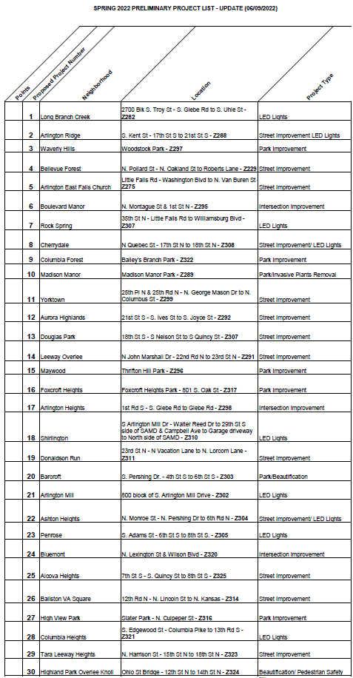

**APPENDIX B**

**ANP 1ST PRIORITY PROJECT LIST - POST SPRING 2024 FUNDING ROUND (UPDATE 10/24/2024)**

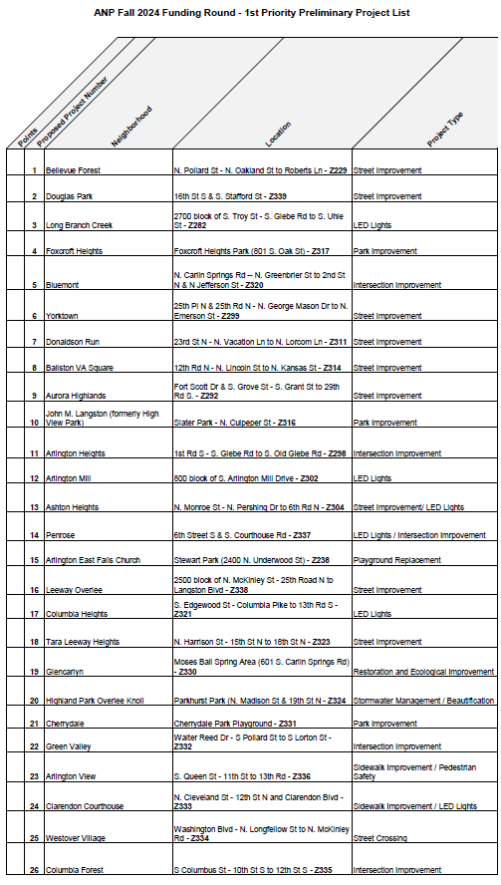

**APPENDIX C**

