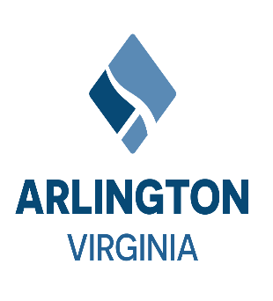

Arlington County, Virginia

*Arlington will be a diverse and inclusive world-class urban community with secure, attractive residential and commercial neighborhoods where people unite to form a caring, learning, participating, sustainable community in which each person is important*.

**Meeting Minutes for 9th February 2023**

**Audit Committee Meeting**

**Audit Committee Members:**

*Christian Dorse, Audit Committee Co-Chair (Present)*

*Takis Karantonis, Audit Committee Co-Chair (Present)*

*Mark Schwartz, County Manager (Present)*

*Maria Meredith, Management & Finance Director (Present)*

*John Tuohy, Community Member (Present)*

*Luanne Lohr, Community Member (Not Present)*

*John Vihstadt, Community Member (Not Present)*

*William (Bill) Wiggins, Community Member (Not Present)*

**Administrative Attendees:**

*Jim Shelton, County Auditor (Present)*

*Lynne Porfiri, Chief of Staff (Present via Video Conference)*

*Mason Kushnir, County Board Deputy Clerk (Present via Video Conference)*

***Approval of Minutes from Prior Meeting:***

Minutes to be submitted on the 8th of June 2023 Audit Committee Meeting.

***Summary:***

***County Auditor’s Introduction:*** *A PPT and document was shared as part of the introduction, it was also uploaded to the County Auditor’s webpage. The PPT detailed the Auditor’s background and the audit process going forward. The audit process will include data-driven, cost-containment, and revenue-enhancement approaches. These approaches to the audit execution and the Annual Audit Work Plan methodology were also covered. The proposed time for presentation of the Annual Audit Work Plan to the Audit Committee Co-Chairs is mid-May 2023. The Annual Audit Work Plan will be presented to the Audit Committee at the 8th of June 2023 Audit Committee Meeting. The first quarter FY2023 audit kick-off will be (1st July 2023). The audits in the Work Plan will kick off at the start and each quarter and close at the end of each quarter. The audit reports will include measurable and actionable recommendations integral to performing adequate audit follow-ups. The Auditor explained; that management will be invited, requested, and encouraged to participate in the Audit Committee Meetings to present management’s responses before a request for approval of the report is made to the Audit Committee.*

***Questions & Answers:***

***Audit Committee Member, County Manager Mr. Mark Schwartz Question****: How do the current data requests from departments mesh with developing your work plan?*

***Audit Committee Member, Management & Finance Director Ms. Meredith Statement***: *It is an atypical approach to solicit data before approving an audit work plan.*

***County Auditor’s Responses:*** *I am developing a repository of County data (which does not exist). This is an integral part of developing meaningful work plans. These data are being used to profile the department's financial, transactional, and operational data to identify magnitudes and exposures for the data-driven audit approach that will be used.*

***Next Audit Committee Meeting:***

*The next meeting of the Audit Committee was scheduled for the 23rd of February 2023. The committee will meet to discuss the External Audit presentation from Cherry Bekaert.*

*Adjournment*

Without objection, at 5:23 PM, Mr. Karantonis adjourned the 9th of February 2023 Audit Committee Meeting.

Minutes submitted by: Mason Kushnir, Deputy County Clerk

*~END~*