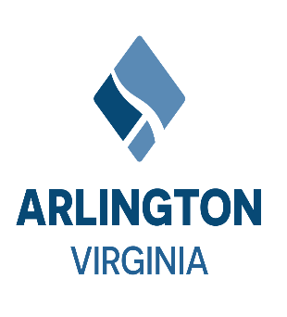

Audit Committee Meeting

**Meeting Date & Time:**

Thursday, February 8, 2023 / 4:30 pm – 6:00 pm

**Meeting Location:**

Conference Room 311 on the 3rd Floor of the Bozman Building

2100 Clarendon Blvd., Arlington, VA 22201

Virtual: [Click here to join the meeting](https://teams.microsoft.com/l/meetup-join/19%3ameeting_ZDRlMjNhYzAtNTQxMi00YWU0LTg1OWUtZjE2NDJmNjcyZGUy%40thread.v2/0?context=%7b%22Tid%22%3a%2280354804-1fdf-428e-9f5f-5091e994cf54%22%2c%22Oid%22%3a%224209dc89-1934-4ba7-ad78-4f68545975d4%22%7d)

**AGENDA**

1. Call to Order
2. Approval of September 28th, 2023, Meeting Minutes
3. Introduction of Committee Co-Chairs
4. CliftonLarsonAllen External Audit Update
5. DMF Internal Audit and FFWA Hotline Annual Update
6. Co-chairs report on vacancy of County Auditor position
7. Committee Members Question and Answer Session
8. Next Audit Committee Meetings
   * March 28, 2024, @ 4:30 pm

Adjourn