*Staff Draft 1*

MOUNT OLIVE BAPTIST CHURCH

IN 1873, A SMALL CONGREGATION FORMED THE ANTIOCH BAPTIST CHURCH IN FREEDMANS VILLAGE, A COMMUNITY ESTABLISHED BY THE FEDERAL GOVERNMENT FOR FREE BLACKS DURING AND AFTER THE CIVIL WAR. SOON AFTER THE CHURCH WAS BUILT, THE FEDERAL GOVERNMENT DISBANDED THE COMMUNITY. THE CONGREGATION BUILT A NEW CHURCH RENAMED AS MOUNT OLIVE IN 1893. IN 1942, THE GOVERNMENT AGAIN REQUISITIONED THE CHURCH’S LAND, NOW FOR THE CONSTRUCTION OF THE PENTAGON.

THE CONGREGATION BUILT THIS CHURCH IN LATE 1944. MOUNT OLIVE ADAPTED AND FLOURISHED, A CHAMPION FOR CIVIL RIGHTS AND THE FIRST BLACK CHURCH IN ARLINGTON TO BROADCAST BY RADIO. FOR 150 YEARS, MOUNT OLIVE HAS SUPPORTED MENTAL HEALTH AND AFFORDABLE HOUSING SERVICES, AND PROVIDED MEALS, SCHOLARSHIPS, AND FAITH SUPPORT.

Erected in 2023 by Arlington County, Virginia

*(118 Words)*

*For an aluminum marker we have a maximum allotment of 36 characters (including punctuation and spaces) on each of 21 lines, see next page for draft text set into the marker outline.*

*See page 2 for edits from Gerry Laporte (HALRB Marker Committee) and the applicant (Mount Salvation Baptist Church).*

*See page 3 for staff proposed text based on edits from applicant and Marker Committee.*

*Staff Draft 1 set in marker outline for character count*

*(Proposed text too long)*

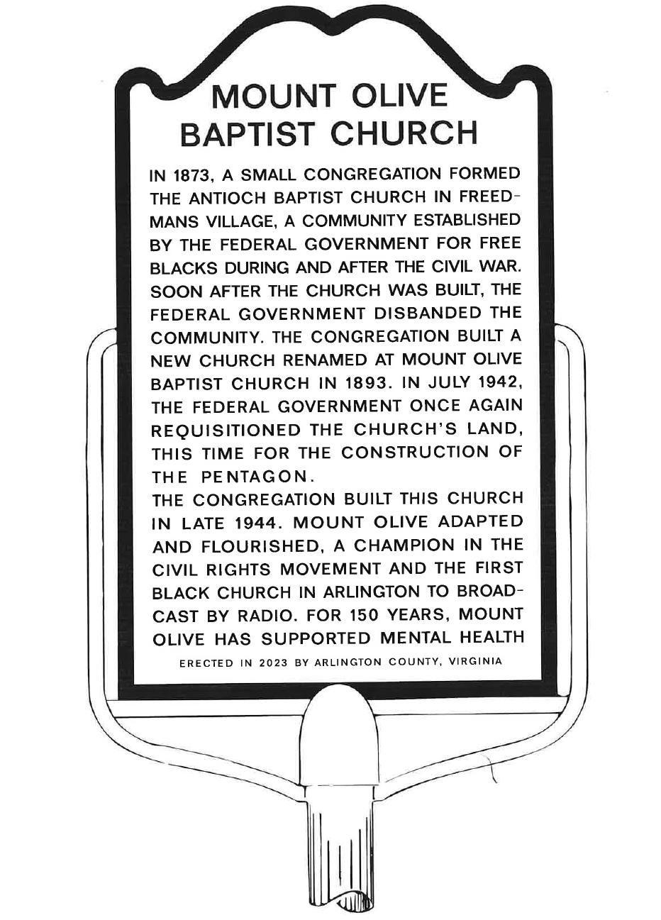

*Gerry Laporte Draft 1 Edits*

MOUNT OLIVE BAPTIST CHURCH

IN 1873, A GROUP OF 85 PERSONS FORMED THE ANTIOCH BAPTIST CHURCH IN FREEDMAN’S VILLAGE, A COMMUNITY ESTABLISHED BY THE FEDERAL GOVERNMENT FOR FREE BLACKS DURING THE CIVIL WAR. SOON AFTER THE CONGREGATION BUILT A CHURCH, THE FEDERAL GOVERNMENT DISBANDED FREEDMAN’S VILLAGE. THE CONGREGATION BUILT A NEW CHURCH NEARBY IN 1893 AND RENAMED IT MOUNT OLIVE. IN 1942, THE GOVERNMENT AGAIN APPROPRIATED THE CHURCH’S LAND, THIS TIME FOR THE CONSTRUCTION OF THE PENTAGON.

THE CONGREGATION BUILT THIS CHURCH IN LATE 1944. MOUNT OLIVE ADAPTED AND FLOURISHED, A CHAMPION FOR CIVIL RIGHTS AND THE FIRST BLACK CHURCH IN ARLINGTON TO BROADCAST BY RADIO. FOR 150 YEARS, MOUNT OLIVE HAS SUPPORTED MENTAL HEALTH AND AFFORDABLE HOUSING SERVICES, AND PROVIDED MEALS, SCHOLARSHIPS, AND FAITH SUPPORT.

Erected in 2023 by Arlington County, Virginia

*(122 words.)*

*Applicant Draft 1 Edits*

MOUNT OLIVE BAPTIST CHURCH

DURING THE RECONSTRUCTIN ERA IN 1873, A SMALL CONGREGATION OF FORMERLY ENSLAVED AFRICAN AMERICANS ORGANIZED THE ANTIOCH BAPTIST CHURCH FROM THE “OLD BELL CHURCH.” IT WAS LOCATED IN FREEDMAN’S VILLAGE, FORMERLY THE ROBERT E. LEE PLANTATION. THIS MODEL COMMUNITY WAS FORMED BY THE FEDERAL GOVERNMENT TO SUPPORT NEWLY FREED AFRICAN AMERICANS DURING AND AFTER THE CIVIL WAR. THE CHURCH RENAMED ITSELF MOUNT OLIVE BAPTIST CHURCH IN 1873 AND ACQUIRED LAND WHERE A NEW BUILDING WAS CONSTRUCTED IN 1893. MOUNT OLIVE ADAPTED AND FLOURISHED UNTIL 1942 WHEN THE FEDERAL GOVERNMENT CONFISCATED THE LAND TO BUILD THE PENTAGON.

MOUNT OLIVE RELOCATED TO THIS SITE, ERECTING THE CURRENT EDIFICE IN 1944 IN THE GOTHIC REVIVAL STYLE. THE PRESENT CAMPUS HAS SERVED AS A HUB FOR THE CHURCH’S COMMITMENT TO ITS CHRISTIAN MISSION OF UPHOLDING HUMAN DIGNITY, PROVIDING SPIRITIAL SUPPORT, AND ADVOCATING FOR HUMAN RIGHTS.

Erected in 2023 by Arlington County, Virginia

*(141 words.)*

*Staff Proposed Draft 2 based on comments*

MOUNT OLIVE BAPTIST CHURCH

IN 1873, 85 FORMERLY ENSLAVED AFRICAN AMERICANS FORMED THE ANTIOCH BAPTIST CHURCH IN FREEDMANS VILLAGE, A MODEL COMMUNITY ESTABLISHED BY THE FEDERAL GOVERNMENT FOR FREE BLACKS DURING RECONSTRUCTION. SOON AFTER THE CHURCH WAS BUILT, THE FEDERAL GOVERNMENT DISBANDED THE VILLAGE. THE CONGREGATION BUILT A NEW CHURCH RENAMED AS MOUNT OLIVE IN 1893. IN 1942, THE GOVERNMENT SEIZED THE CHURCH’S LAND FOR THE CONSTRUCTION OF THE PENTAGON.

THE CONGREGATION BUILT THIS GOTHIC REVIVAL CHURCH IN LATE 1944. MOUNT OLIVE ADAPTED AND FLOURISHED, A CHAMPION FOR CIVIL RIGHTS AND THE FIRST BLACK CHURCH IN ARLINGTON TO BROADCAST BY RADIO. FOR 150 YEARS, MOUNT OLIVE HAS PURSUED ITS MISSION OF UPHOLDING HUMAN DIGNITY, PROVIDING SPIRITUAL SUPPORT, AND ADVOCATING FOR HUMAN RIGHTS.

*(118 words.)*

*Staff Proposed Draft Text 2 in the marker format\**

*(\* This text exceeds the allowed space by 1 line. Suggestions welcome.)*

1. IN 1873, 85 FORMERLY ENSLAVED AFRICAN
2. AMERICANS FORMED THE ANTIOCH BAPTIST
3. CHURCH IN FREEDMANS VILLAGE, A MODEL
4. COMMUNITY ESTABLISHED BY THE FEDERAL
5. GOVERNMENT FOR FREE BLACKS DURING
6. RECONSTRUCTION. SOON AFTER THE CHURCH
7. WAS BUILT, THE FEDERAL GOVERNMENT
8. DISBANDED THE VILLAGE. THE CONGRE-
9. GATION BUILT A NEW CHURCH RENAMED AS
10. MOUNT OLIVE IN 1893. IN 1942, THE GOV-
11. ERNMENT SEIZED THE CHURCH’S LAND FOR
12. THE CONSTRUCTION OF THE PENTAGON.
13. THE CONGREGATION BUILT THIS GOTHIC
14. REVIVAL CHURCH IN LATE 1944. MOUNT
15. OLIVE FLOURISHED, A CHAMPION FOR
16. CIVIL RIGHTS AND THE FIRST BLACK
17. CHURCH IN ARLINGTON TO BROADCAST
18. BY RADIO. FOR 150 YEARS, MOUNT
19. OLIVE HAS PURSUED ITS MISSION OF
20. UPHOLDING HUMAN DIGNITY, PROVIDING
21. SPIRITUAL SUPPORT, AND ADVOCATING
22. FOR HUMAN RIGHTS.

Erected in 2023 by Arlington County, Virginia