Standard Operating Procedures for Emergency Shelters During

Hypothermia Season

**Includes COVID-19 Protocols**

**Hypothermia Shelter Program Background**

Arlington county is committed to assisting individual adult women and men who are experiencing homelessness during the cold winter/ hypothermia (Hypo) season. The County anticipates the 2024-2025 Hypothermia season will open from **November 1, 2024 through March 31, 2025**. The central mission of the hypothermia program is to provide safe, secure temporary housing and support to address an immediate crisis for homeless adults who would otherwise be living in conditions not meant for human habitation during life-threatening temperatures. Arlington’s hypothermia prevention and response programs provide emergency shelter, meals and crisis intervention during the coldest months of the year. The program provides shelter, two hot meals (breakfast and dinner) and a bagged lunch. Arlington also provides access to case management and medical treatment as well as mental health and substance abuse services.

Due to the ongoing COVID-19 pandemic, Arlington County has maintained its modified operations to safely accommodate shelter guests during the pandemic and throughout the hypothermia season.

During hypothermia season, the Homeless Services Center (HSC), operated by PathForward, and Residential Program Center (RPC), operated by New Hope Housing, shall accept all individuals experiencing homelessness regardless of whether they are Arlington residents. **Once the immediate hypothermia need has resolved, that is the weather is no longer or “feels like” below 32-degree Fahrenheit, all non-Arlington County residents must be connected to their jurisdiction of origin and exit Arlington shelters after 96 hours of an approved entry placement.** During their stay at the HSC and RPC, shelter guests will be provided similar services as those provided to participants of the Day Program*. Arlington’s goal is to end homelessness. To that end, all guests participating in the hypothermia program shall be encouraged by shelter staff to transition to the year-round homeless services program.

As the need arises, the RPC shelter shall be responsible for accepting the overflow of up to 6 hypothermia guests from the HSC shelter. The HSC shall be responsible for overflow transportation from the HSC to the RPC shelter.

Staffing: **HSC-Hypo** must provide at least 3 dedicated staff to hypothermia oversight.

**RPC-Hypo** overflow must provide at least 1 dedicated staff to hypothermia oversight. Routine security walk-throughs are required for both shelters.

Below are the procedures that all shelter staff must comply with for all hypothermia guests in Arlington’s shelters. Please do not hesitate to contact Arlington County’s Continuum of Care Services Coordinator at [DHSSheltercontracts@arlingtonva.us](mailto:DHSSheltercontracts@arlingtonva.us). If you have any questions regarding these standard operating procedures.

**Program Entry**

Arlington County’s Hypothermiaprogram serves single adults on a first-come first-serve basis and Arlington County residents are prioritized for hypothermia placement and year-round shelter. All individuals seeking placement are initiated at the HSC-Hypo program regardless of their length of stay must undergo the admission process. Overflow entry procedures for RPC will follow the outlines as described for the HSC-Hypo program. All entry and exits by clients will be through the main shelter entrance to control visitor flow.

That includes/consists of:

1. **HSC-Hypo** program will make use of 2020-A 14th Street North 7th floor space for approximately 25 single adults. This includes (13 males and 12 females). Please refer to below attached floor plan.
   1. **RPC-Hypo** program will make use of 1554 Columbia Pike for approximately 15 single adults.
2. Points of entry and exits: All **HSC and HSC-Hypo** program guests will make use of main 2020-A building entry point. **HSC-Hypo** program guests must be escorted to the 7th floor designated hypothermia space.
   1. **RPC-Hypo** program guests will make use of the main building entrance as an entry and exit access point.
   2. All visitors flow must be monitored.
   3. All guests and staff utilizing shelter elevators should ensure appropriate social distancing of no more than 2 per person at any given time.
3. Upon entering shelter for hypothermia programs, all guests shall:
   1. Have temperature checks and documented logs of all incoming guests maintained daily.
   2. Be offered COVID-19 tests for their first entry (and then offered weekly), or at future admissions if not sleeping in shelter on a consistent basis. (HSC staff will also provide testing for clients who are transferred to RPC hypo overflow).
      1. Clients who test positive will be offered isolation spaces on site per the CoC Nursing staff guidance.
   3. Be searched, as well as their personal belongings including but not limited to luggage, bags, purses, satchels, fanny packs, briefcases, etc. The following protocol should be followed for searches:
      1. At least two staff members must be present for all searches and at least one or both must be female if the guest is a female.
      2. All pockets should be emptied and turned inside out upon entry into shelter, socks/ankles and waistband should be shown to monitor
      3. All consideration for the guest’s dignity will be made.
      4. If the contraband is of an illegal nature, the Arlington Police will be notified, and the contraband will be turned over to them
      5. If a guest has contraband, the guest may be asked to leave the shelter or otherwise be subjected to disciplinary action.
4. No one shall be admitted if he/she possess weapons, alcohol or illegal drugs, or other prohibited items. Shelter staff must notify the Arlington County Police through their non-emergency number 703-558-2222 whenever an individual is denied placement in the shelter because of a weapon possession;
5. If the individual is permitted to remain in the shelter, all belongings will be placed into a Bedbug treatment bag for 2 hours;
6. Staff must check the guest’s name through the Homeless Management Information System (HMIS);
7. Staff must update the bed list in HMIS within 8 hours of guests’ entry and exit so that bed lists remain current in real-time;
8. Staff must complete a HUD assessment touchpoint in HMIS of the guest;
9. Staff must check the individual’s name on the national registry of sexual offenders;
10. All hypothermia guests shall be strongly encouraged to transition to the year-around shelter program (discussed below); and,
11. All guests must agree to fully comply with Arlington County’s and the shelter’s expectations for the hypothermia program.

**Managing the Overflow of Hypothermia Guests from the HSC to the RPC**

Whenever the HSC-Hypo program has reached the capacity of 25 hypothermia guests, the HSC staff must arrange with RPC staff to receive up to 6 hypothermia overflow guests. The HSC shall be responsible for transportation to and from the HSC to the RPC shelter for all hypothermia overflow guests. If all hypothermia shelter beds are occupied in Arlington County, HSC staff will coordinate with neighboring jurisdictions to find temporary alternative shelter for guests. Any Arlington County resident will be returned to Arlington County once space becomes available.

**Inclement Weather Events**

Weather events that post an extreme risk to the safety of those sleeping outdoors may occur during times when all hypothermia beds are occupied, and year-round beds are not. In those circumstances, DHS, HSC, and RPC staff will:

1. Work to ensure that Arlingtonians in hypothermia beds will be placed in year-round beds at each facility to free up hypothermia spaces prior to the weather event;
2. Coordinate with each other to determine the transfer of guests (reference section above for process) prior to the weather event;
3. If both facilities are at maximum capacity for year-round, hypothermia and overflow, HSC and/or RPC will notify DHS.

DHS will determine if the weather events requires coordination with the Arlington County Sheriff’s Office for temporary use of the Arlington County Detention Center (for males only). The Continuum of Care Services Coordinator or DHS-designee will be the person to coordinate these efforts. DHS will inform HSC and RPC staff of any authorization for use and coordinate logistics.

**Justice-involved Adults**

During hypothermia season, Arlington County will commit to serving a maximin of 3 justice-involved adults nightly who are experiencing homelessness who may not be residents but are committed to probation or parole in Arlington. Due to the close proximity of a licensed childcare facility to the Homeless Service Center (HSC), **sex offenders are not permitted at the HSC at all.** Both the HSC and Residential Program Center (RPC) are responsible for conducting real-time intake screenings for sex offenders across all project types. Any offenders seeking services at the HSC must be immediately directed to the County’s Clinical Coordination Unit (CCP) for additional screening, assessment and possible placement. **RPC is only permitted to accommodate a maximum of 4 sex offenders at a time.**  Probation and Parole District 10 or Arlington Community Corrections must seek approval from the Arlington County Department of Human Services before any justice-involved individuals are placed in the HSC-Hypo program. Arlington County staff will notify HSC staff in writing with the name of the justice-involved adults who will be staying in the hypothermia program.

**Schedule**

All hypothermia guests must follow the shelter’s rules and schedule. The daily schedule for hypothermia guests is as follows:

* *Wake-up time:* Weekdays-6:00am; Weekend-7:00am
* *Breakfast:* 6:30am-7:30 am
* *Departure time*: 9am daily - OR -
  + Day Programming: 9am -4pm daily*
* *Evening Hypothermia return*: Weekdays-4pm-6:00am; Weekend-4pm-7:00am

**Meals may vary between catered bagged meals or onsite prepared meals. All mealtimes must be staggered, and proper social distancing must be sustained.**

*Guests in the HSC and RPC-Hypo program have the option to remain in shelter during the day if they participate in the Day Program with appropriate social distancing procedures from 9am-4pm. **HSC- Hypo** day programming will take place in designated 2nd and 7th floor open spaces where beds and floor cots are to be removed to accommodate the placement of limited tables and chairs for shelter services.

**Shelter Cleaning Procedures during Covid-19 Pandemic**

Shelter providers must always ensure cleaning and the appropriate sanitary conditions of Arlington County shelters, this includes the outlined terms and conditions per the County’s shelter agreements.

Additionally, shelters should adhere to CDC guidelines for cleaning procedures referenced [here](https://www.cdc.gov/coronavirus/2019-ncov/community/homeless-shelters/plan-prepare-respond.html)

**Access to Year-Round Shelter**

Guests are strongly encouraged to transition to available year-round shelter beds either at the HSC or RPC. To transition to a year-round shelter bed, guests must go to the Arlington County Department of Human Services- Community Assistance Bureau to complete an intake via the Centralized Access System (CAS). Upon completion of their intake, guests will receive a referral to either the HSC or RPC, depending on availability. Guests are required to accept the placement options to HSC or RPC. No wait list will be maintained for any shelter as the same services are offered at both the HSC ad RPC.

**Hypothermia Procedures to Transition Clients to Year-round Shelter Placement**

Throughout the hypothermia season, shelter staff will transition HSC-Hypo guests and RPC overflow guests (when applicable) to year-round emergency shelter beds. Hypothermia guests will complete intake over the phone with Arlington County Department of Human Services (DHS) before transitioning to a year-round bed if they have not already done so within the previous 30 days.

Staff will:

* Prior to being moved from hypothermia to shelter, the guest will receive a letter explaining the transition process, explained below.
* Contact the Clinical Coordination Program Manager at DHS by phone and/or email to provide notice that a current hypothermia guest will be completing an intake.
  + If a guest has been out of shelter and unconnected to homeless services for more than 30 days, they must go to DHS to complete intake again they must go to DHS to complete intake again.
  + If a guest has been moved to shelter on temporary basis and is required to go to DHS, the staff can contact the Clinical Coordination Program Manager to confirm the guest has completed intake at DHS. Case Management can begin once this has been confirmed.
* The Clinical Coordination Program Manager shall be informed via email the same day whenever a hypothermia guest declines a year-round shelter placement.

**Transition Process**

Prior to the end of hypothermia season, it may be necessary to transition a high volume of guests from hypothermia shelter to year-round shelter. The following process should be observed:

* Shelter staff will email the Arlington County Clinical Coordination Program Manager and confirm that the hypothermia guest is an Arlington resident.
* The HSC Senior Shelter Director will arrange various call times with the Clinical Coordination Program manager to have screening and intakes, a maximum of 5 hypothermia guests per day, completed over the phone.
* Each shelter will send the vacancy list to the Clinical Coordination Program Manager no later than 10 am Monday-Friday.

**HSC-Hypothermia 7th floor plan**

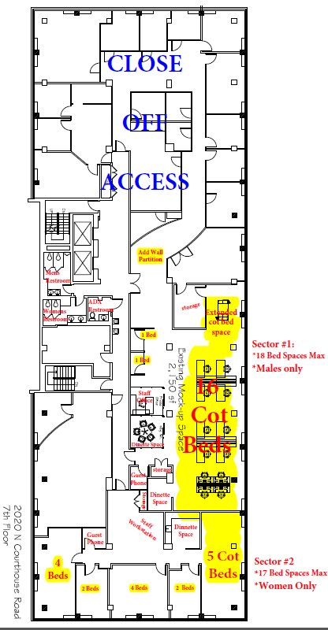

**ARLINGTON COUNTY COC COVID-19 (CORONAVIRUS) QUICK GUIDE**

**FOR HOMELESS SERVICES PROVIDERS**

The Arlington County CoC is providing this quick guide to its homeless providers based on the best available information as of October 2024.

**RESOURCES**

***Local:*** Updates from Arlington County regarding COVID-19 can be found [here](https://www.arlingtonva.us/Government/Programs/Health/COVID-19). All staff and shelter guests should register for Arlington Alert [here](https://www.arlingtonva.us/Government/Programs/Emergency/Arlington-Alert?BestBetMatch=arlington%20alerts|d2f86bd7-6525-489c-b1eb-fbe9efd2bbfb|6244aa32-b2d4-441b-b20e-1096256a4671|en-US) to receive free emergency alerts and information. Staff or guests with questions about COVID-19 can reach out to the COVID-19 Hotline at 703-228-7999.

***State:*** Guidance from the Virginia Department of Health for homeless shelters can be found [here](https://www.vdh.virginia.gov/coronavirus/).

***Federal:*** Guidance from the U.S. Department of Housing and Urban Development can be found [here](https://www.hudexchange.info/homelessness-assistance/diseases/#covid-19-community-planning-and-preparedness) and the CDC can be found [here](https://www.cdc.gov/covid/?CDC_AAref_Val=https://www.cdc.gov/coronavirus/2019-ncov/community/homeless-shelters/).

**SHELTER & DROP-IN SHOWER/LAUNDRY PROGRAMS**

**All emergency shelters in Arlington County are implementing enhanced and preventive cleaning protocols outlined in the** [**Infectious Disease Toolkit for CoCs Preventing and Managing the Spread of Infectious Disease Within Shelters**](https://files.hudexchange.info/resources/documents/Infectious-Disease-Toolkit-for-CoCs-Preventing-and-Managing-the-Spread-of-Infectious-Disease-within-Shelters.pdf)**. As a preventive safety precaution, all program participants and staff shall follow the guidance below, emphasizing preventive measures (screening, mask wearing, social distancing, and hand washing); health education; and vaccination.**

**Emphasis on Prevention in Shelters:**

Efforts to maintain social distancing, educate clients on the prevention and transmission of COVID-19, and provide access to vaccines and boosters in shelter should continue. Shelter staff are advised to:

* Complete COVID-19 screenings (see page 6) at intake.
* Conduct daily temperatures and general health check ins of all staff and clients for symptoms and elevated temperatures. Notify CoC nurses for any clients who report or are observed not feeling well or are symptomatic.
* Limit visitors to essential personnel and service providers during periods of high rates of community transition.
* Work with PathForward nursing staff/CoC Nursing Staff to conduct site visits for consultation and advisement on methods to maintain a focus on prevention in congregate or shared spaces.
* Encourage mask wearing and limit congregating among program participants in shared spaces.
* Provide PPE, cleaning supplies and hand sanitizer to program participants, staff and volunteers.
* Assertively engage program participants to remain diligent in communicable disease prevention efforts and work with clients to explore concerns or barriers to vaccination.
* Guidance on assisting persons who refuse preventive strategies listed above is offered on page 8.
* Refer to page 10 for additional suggestions & guidance on precautions for family shelter or other congregate spaces.

**Vaccines in Shelter:**

Shelters continue to remain the last resort option for vulnerable community members who do not have housing. To remain low barrier and Housing First, shelters cannot mandate vaccinations as a condition of their stay in shelter. And while shelter staff cannot directly ask about client’s vaccine status, staff can proactively offer assistance in getting clients vaccinated. As program participants express interest in getting vaccinated, staff can assist by capitalizing on client’s motivation by providing transportation assistance to vaccine sites (found here: <https://www.arlingtonva.us/Government/Programs/Health/COVID-19/COVID-19-Vaccine>).

PathForward nursing staff may also reach out to providers directly to coordinate vaccine clinics should sufficient need be presented (at least 10 persons). Program staff are strongly encouraged to help clients remember and get to scheduled clinics to prevent waste of vaccine.

**Shelter Configuration to Maximize Prevention and Reduce Transmission:**

Definitions:

*Isolation:*separates sick people with a contagious disease from people who are not sick.

*Quarantine:*separates and restricts the movement of people who were exposed to a contagious disease to see if they become sick. These people may have been exposed to a disease and do not know it, or they may have the disease but do not show symptoms.

|  |
| --- |
| 1. **Maintain Routine Infection Control Practices**    * Wash hands often for 20 seconds or use hand sanitizer.    * Cover coughs and sneezes with a tissue and dispose of tissues immediately after use.    * Use appropriate personal protective equipment.    * Clean equipment.    * Clean environment. |
| Add additional layers of COVID-19 transmission prevention strategies  * + Separate individuals by more than 3-6 feet when possible.   + Arrange beds so that individuals lie head to toe relative to each other.   + Where needed, temporary physical barriers can be created between beds, using sheets or curtains. |
| Isolation at shelter site: Should an outbreak occur, it may be necessary to isolate persons who are COVID positive or presumed positive at shelter locations. Determinations will be made in partnership with Arlington County staff and Public Health staff, with consultation from CoC Nursing staff.  * + Designate staff member(s) to be caregivers to persons in isolation.   + Conduct wellness checks, at least daily, particularly for persons isolating/quarantining in separate rooms or units.   + Wear a surgical mask when providing direct care within 3 feet.   + Have hand sanitizer, Kleenex and waste can or bag at each bedside of the sick.   + Ensure 6 ft distance between isolating clients and non-isolating clients with a physical barrier between groups   + Increase ventilation in the facility to the extent possible.   + Call 9-1-1 for persons who exhibit serious symptoms: Trouble breathing; persistent pain or pressure in the chest; new confusion; inability to wake or stay awake; pale**,** gray, blue-colored skin, lips, or nail beds, depending on skin tone.   *Two and three-zone isolation strategy examples are included on page 7 as potential examples.* |
| **Hotels may be available on a case by case basis and will depend on available funding and hotel vacancies.**  DHS staff will work with Public Health and CoC Nursing staff to review numbers of confirmed COVID positive cases and shelter capacity at time of outbreak to explore off-site isolation/quarantine strategies as needed. |

**COVID TESTING AND QUARANTINE/ISOLATION PROTOCOLS**

**TESTING & ISOLATION:**

* **Please note that we will not be conducting COVID testing as clients come into Hypothermia.** However, if a client comes in and reports that they are feeling sick or appear sick (coughing, sneezing, runny nose), staff should offer them a COVID test kit so that they can test themselves.  Please ask to see the result and/or assist with instructions on how to do the self test.
* If the client declines to do the test or the test is negative but they have symptoms/feeling sick, please ask them respectfully to put on a mask and have them sleep at a greater distance from other clients.
* Please write their name on the Nursing Services Sign up log in the Hypothermia Medical Binder and PathForward’s Nurse Practitioner will follow up with the HSC client the next business day.
* If the client does test COVID positive, staff should isolate them on the 7th floor of HSC. The three rooms directly in the back will be designated as COVID isolation rooms for Hypothermia clients.
* At HSC, any COVID positive clients on the 3rd floor will isolate on the second floor in the client rooms/classroom.
* At RPC, any COVID positive clients should be isolated using one of the conference rooms.
* **If we have more than 2 cases of COVID positive clients (shelter and hypothermia, staff should conduct shelter wide COVID testing)**

**DOCUMENTATION:**

* Documentation of positive cases should be kept in the medical binder with the following information:
  + Full Name
  + DOB
  + Symptoms
  + Date Symptoms Started
  + Test Date
  + Client Contact Information
* Information should be sent to PathForward’s Nurse Practitioner so that they can be reported to Arlington County Public Health.
* Used COVID self test kits should be disposed of in a regular trash receptacles.

|  |  |  |  |
| --- | --- | --- | --- |
|  | **COVID-19 PROTOCOLS** | | |
| **Point of Contact** | **Prevention: Screening & Testing** | **Response for Positive Test Cases** | **Prevention: Education and Vaccination** |
| **CAS intake/ assessment** |  | CCP staff will coordinate with Isolation/Quarantine hotel, CoC partner as applicable, and CoC Nursing staff. | All clients will be notified and encouraged to connect with shelter staff for information on how to schedule a COVID-19 vaccine. |
| **Intake/Initial Program Entry** | All clients will be screened for COVID-19 symptoms or contacts (see attached screening tool).  Shelters will maintain an isolation/ quarantine space for clients who aren’t interested in or do not voluntarily show their vaccination cards until a rapid antigen test can be completed. | Follow Isolation at Shelter Site guidance if confirmed positive test result. | Offer information regarding scheduling a COVID-19 vaccine. If the client is not interested or say they have been vaccinated but don’t show their card voluntary, please place them in a isolation/quarantine space until a screening test can occur. |
| **Ongoing** | Monthly testing will occur for all clients, unless there has been a positive test or someone presents with symptoms at which point testing will occur weekly.  Intake screening questionnaire (see attached) should also be utilized for any extended leave guests from shelter (overnight/passes) and when clients present with symptoms. | Follow Isolation at Shelter Site guidance (above) if confirmed positive test result. | Ongoing case management should include discussions about health, prevention (vaccination, mask wearing, social distancing, and hand washing), and COVID-19 resources.  Staff and clients should have up-to-date information regarding COVID and relevant variants. |

**STAFF & VOLUNTEER SAFETY**

* + All staff should wear masks at work. (Contractors in Arlington County buildings must follow County mandates).
  + Practice social distancing (people should be 6 feet apart). Adjust physical work spaces and tables to ensure this can occur.
  + Staff or volunteers who are exhibiting symptoms should stay home.
  + Staff or volunteers who become sick at work should go home.
  + Staff that can work remotely should do so according to the organizations HR policy.
  + Working in shifts or working different hours may help to reduce the amount of staff in the same place at the same time.
  + Educate and inform all staff and volunteers on current COVID-19 impacts and relevant variant information.

**Graphics / Posters / Signage from the National Institute of Health**

**Please post prominently in each emergency shelters for staff and guests.**

Website:<https://ors.od.nih.gov/mab/Pages/COVID-19-Resources.aspx>

**NEW CLIENT COVID-19 SCREENING PROTOCOLS QUESTIONNAIRE**

**Name: __________________________ Intake Date:_______________**

**Do you have any of the following:**

|  |  |  |
| --- | --- | --- |
|  | **YES** | **NO** |
| **Fever or chills** |  |  |
| **Fatigue** |  |  |
| **Sore throat** |  |  |
| **Nausea or vomiting** |  |  |
| **Congestion or runny nose** |  |  |
| **Muscle or body aches** |  |  |
| **New loss of taste or smell** |  |  |
| **Shortness of breath or difficulty breathing** |  |  |
| **Cough** |  |  |
| **Headache** |  |  |
| **Diarrhea** |  |  |
|  |  |  |

**Have you had any close contact in the last 14 days with anyone with COVID-19? YES_____ NO____**

**We highly encourage everyone to get a COVID-19 vaccine. We can assist in getting you to and from the vaccination site. Are you interested? YES ____ NO____**

**If the client is not interested or say that they have been vaccinated BUT do not show their vaccination card voluntarily, please place them in a quarantine space.**

**If the client VOLUNTARILY shows their vaccine card, they can be placed directly in the shelter bed.**

Staff Name (completing the intake)

_____________________________

**Examples of Isolation Strategies (Two Zone vs Three Zone)**

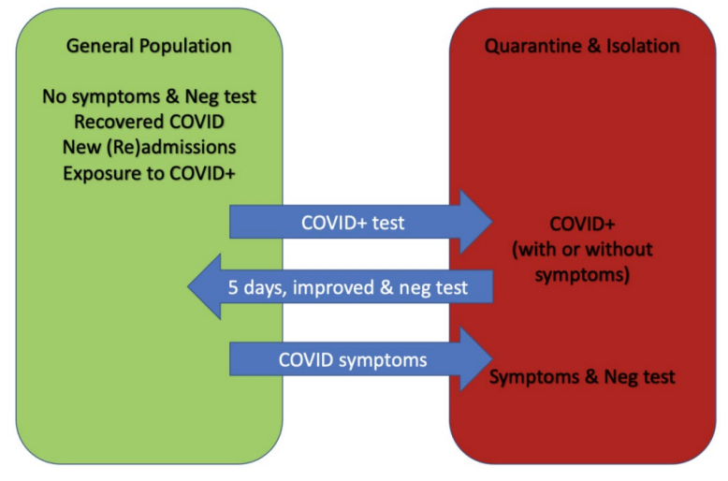

**10**

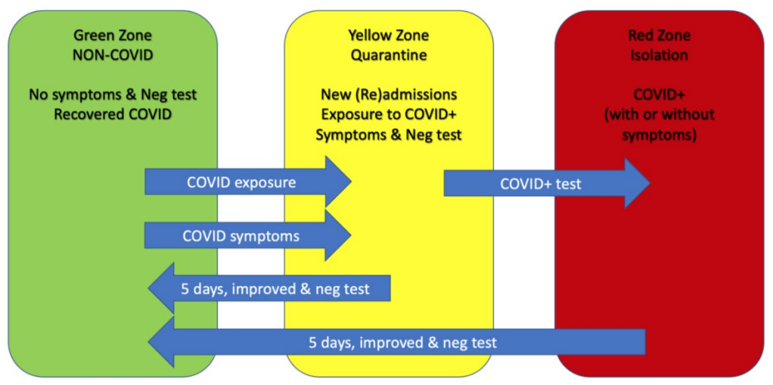

**10**

**10**

Source and additional information about this approach to on-site isolation can be found here: [COVID-19 Planning & Response for Homeless Assistance Providers Office Hours - January 7, 2022 - HUD Exchange](https://www.hudexchange.info/trainings/courses/covid-19-planning-response-for-homeless-assistance-providers-office-hours-January-7-2022/)

**Additional suggestions or considerations for family shelter or congregate spaces:**

* Consider limiting number of people/households in laundry spaces. Time in the laundry area should be brief and limited to loading clothes in the washer and dryer or unloading clothing form the dryer. Folding should be done in a person’s room or unit.
* Consider limiting number of people/households accessing enclosed, pantry spaces at any given time.
* Limit occupants of shared sleeping spaces (1-bedroom units or individual rooms) to one family or 2 single, un-related individuals. Bedrooms should allow for a head to toe sleeping arrangement.
* For 2-bedroom apartments, limit occupants to one family or 4 single, un-related individuals. Each bedroom should still be limited to 2 single individuals with a head to toe sleeping arrangement. Try to limit the number of un-related individuals in each apartment as much as possible.
* For shared or common bathrooms, ask people to wipe down the sink, surfaces, and spray down the shower after use. Provide Lysol spray (or equivalent) and Lysol wipes (or equivalent) to clients.
* In shared or common kitchens, consider limiting number of people using the space at any given time. Consider scheduling or asking people/families to sign up for kitchen/meal times. Individuals should wipe down kitchen surface after use and place dishes in dishwasher or hand wash as soon as possible after use.
* For child enrichment spaces, limit interactions as much as possible. Consider limitations to the number of children or families who can use the space at the same time or utilize social distancing to the extent possible by moving tables and chairs to designated spaces. Children over the age of 2 should be encouraged to wear masks at all times in these enclosed spaces.

Consult with CoC Nursing staff to review any specific recommendations for isolation/quarantine needed as questions arise.