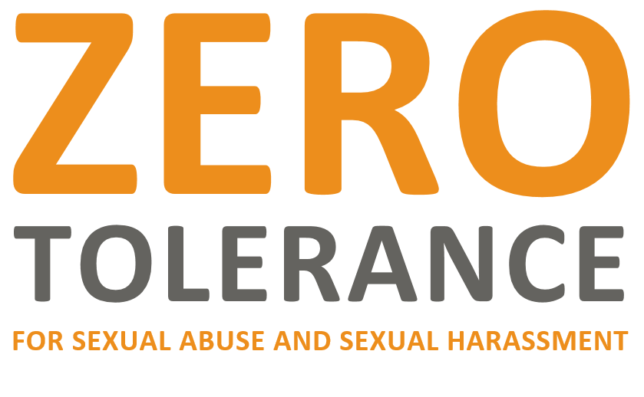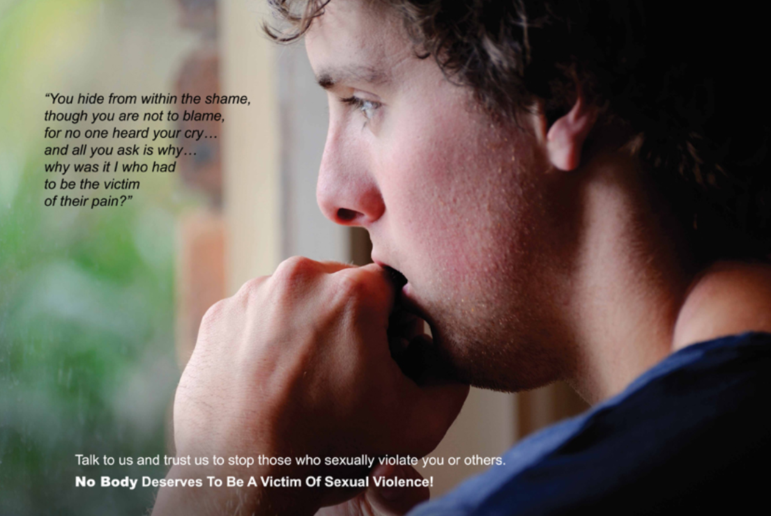

**RIGHT TO REPORT SEXUAL ABUSE AND SEXUAL HARRASSMENT**

If you, or someone you know, are experiencing sexual abuse or sexual harassment, Argus House and the Young Achievers’ Programs want to know. We want you to report right away! Why?

* We want to keep YOU safe; it is our job! It is your right to be free from sexual abuse and sexual

harassment.

* We want to conduct an investigation of the reported incident.
* We want to hold the perpetrator accountable for his/her actions.
* We want to provide YOU with relevant information and support services.

**HOW TO REPORT**

Argus House and the Young Achievers’ Program offer multiple ways to report sexual abuse and sexual harassment. Reports can be made anonymously.

* Report to any staff, volunteer, contractor, or medical or mental health staff.
* Call the Rick Strobach, Deputy Director of Court Services at (703) 228-4360.
* Submit a grievance to any staff person.
* Report to Chris Edmonds, the PREA coordinator.
* Tell a family member, friend, legal counsel, or anyone else outside the facility. They can report on your behalf by calling the PREA HOTLINE (800) 656-4673, available 24/7.
* You also can submit a report on someone’s behalf, or someone at the facility can report for you using the ways listed here or by calling 911.

**VICTIM SUPPORT SERVICES**

The Court Services Unit has partnered with Doorways for Women and Children to provide survivors of sexual abuse with emotional support services. To access these services, contact (703) 237-0881.

*\*Refer to the Argus House PREA Manual 2016 for more information on anonymous reporting and limits to confidentiality for emotional support services.*